972 Chaffee St. New Bedford, MA 02745
Email: cfootprints@comcast.net (508) 525-6797 Cell

2021 The Year of St. Joseph
Spiritual Chaplain: Father Josemaria Barbin
Franciscan Friars of the Immaculate

Pilgrimage to St. Joseph Shrine - Sterling, New Jersey
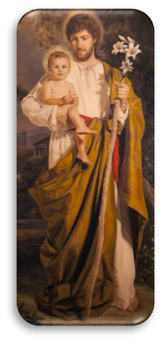
The year 2017 marked the 100th Year Anniversary of the apparition of
Lady in Fatima and this year 2021 we honor St. Joseph.

Saturday July 17, 2021

Cost: $90 per person

Departure from: Mystic Valley Parking Lot –
GPS- 2501 Mystic Valley Parkway, Medford, MA

Time of Departure: 5:00AM

Bring your own lunch!

Includes: Roundtrip Transportation from New Bedford to New Jersey and more
Does not include meals nor personal expenses.

Coach Bus organized by: St. Joseph Church Legion of Mary, Medford, MA

---------------------------------------------- Complete the form –cut the bottom portion and return with payment--------------------------------------------

Please reserve _______ seats for the Pilgrimage/Retreat to St. Joseph Shrine for Saturday July 17, 2021

Name: _______________________________________________________________________________________

Address: ____________________________________________________________________________________

House phone: __________________________________ Cell: _________________________________________

Emergency contact person: ________________________________________ Phone: ________________________

Email: __________________________________________

Any health issues: ______________________________________________________________________

A payment made by check/money order to Catholic Footprints Pilgrimage for $90 per person to reserve a seat and mail to address above with a completed pilgrimage form. Note: Money will not be return if you miss the coach bus at the hour of departure. For more information/register call Edwin at (508) 525-6797 or email us at: catholicfootprints@comcast.net. Payment must be in no later than July 5, 2021. 781 391 1396

